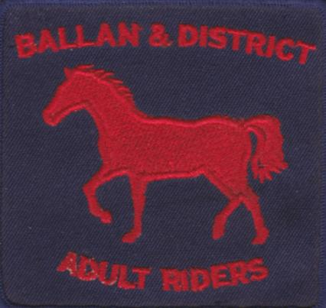
PRESIDENT – -- Lesley Sapsead 0400 014 967
TREASURER – Judith Emond 0408791097
SECRETARY – Josie Gunnell 0418508723
Ballan and District Adult Riding Club
POST OFFICE BOX 108, BALLAN 3342

NEW MEMBER INFO SHEET

HRCAV
We are an affiliated club with the Horse Riding Clubs Association of Victoria (HRCAV). As such we abide by the HRCAV rules & regulations, as well as being covered by their insurance broker, BJS Insurance Brokers Pty Ltd. For full details of rules, regulations, insurance details, forms, competition details and much more visit the HRCAV website www.hrcav.com.au
Memberships
We offer several membership options
Saturday membership- allows attendance at 5 prepaid rallies with the option to purchase further rallies (Venue hire fees may be an extra expense) rallies are held on the 4th Saturday of the month.
WE Membership -Working Equitation meets on the 3rd Tuesday of the month, an initial membership fee is paid then individual clinic attended is purchased prior to the clinic.
Competition Membership- does not allow attendance at rallies but provides insurance.

Grounds/Directions
Unless otherwise specified, Club rallies are held at our club grounds, Ballan Racecourse, Racecourse Road, Ballan. Directions: from Crossroads trading on the Ballan-Geelong Rd take the Gordon Road (head West) for about 1km, then turn right into Racecourse Road, travel for about 1/2km, turn left into Racecourse grounds. Remember to leave gate closed.
Parking
There is ample parking to the right of the driveway in front of day yards. Other parking is available on the left in front of day yards.
Club Rooms/Facilities
Club rooms are located at the end of the driveway, past the harness shed on the left. Toilets are located across from the club rooms in the concrete tanks. The club rooms are shared by other clubs as well; the BADARC has several boxes of equipment, including tea, coffee, sugar, mugs, along with a fridge & BBQ, which members are welcome to use.
Water
Horse water is available from several locations. There is a tap located at the end of the day yards near the entrance to the arena area of the grounds and at the eastern (Ballan) end of the Topsy fenced in area.
Human water is available in the club rooms using the brass tap above the sink.
First Aid
The club has a human/equine first aid kit. The kit is in the filing cabinet in the club rooms.
Horse Facilities
Day yards are available for members use. Flat and jumping lessons are usually held on the sand arena or in the fenced in area. The X-country course is located to the West of the grounds going past the toilets, keeping the toilet on the left, follow track to gate into x-country paddock. Please keep this gate closed at all times, Note there are livestock (sheep) sharing the x-country paddock. All riders are required to wear a body protector vest while out on the x-country course. Members are not to be out on the x-country course on their own.
Club Uniform
The club colours are Navy, Red and White. These colours can be used in any combination of clothing and saddle cloth. A club Logo must be worn when competing, club logo requirement can be found on the HRCAV website.
The club logo (refer to top of page) is available to be embossed onto your own clothing or saddle blanket at ‘Hip Pocket’ workwear, 1265 Howitt Street, Wendouree.
On occasion saddle blankets and clothing are available from the club. There is no uniform requirement to be worn at club rallies. Approved helmet (note new HRCAV ruling below) and appropriate footwear are to be worn at all times when riding.
There is no official uniform for competing (apart from our club colours); however when competing in HRCAV events, HRVAC rules apply which includes the club logo to be displayed on either rider or saddle blanket see website for more details www.hrcav.com.au
Helmets
Approved equestrian helmets must comply with the following standards: AS/NZS 3838 (AU), ASTM F 1163 (USA), PAS 015 (UK) and VG1 (Europe). The EN 1384 (Europe) standard is only acceptable for helmets which were manufactured prior to 2016.
Members are reminded that helmets should be replaced following a fall and that the generally accepted usable life of most helmets is 5 years.

Grading & Competitions
You will be issued with HRCAV Membership Cards shortly after becoming a member. These cards have to be completed by a level assessor if you wish to compete in HRCAV events. Grading is carried out at the members own expense & time. Our club often has instructors who are also HRCAV level assessors and by prearranging may be able to grade you and your horse at a rally, there is usually a fee for this service by the instructor. A full listing of level assessors is available at the HRCAV website www.hrcav.com.au
Rally Day Requests
In the weeks prior to a rally, the Rally Co-ordinator will email members re rally details. Members are required to respond to the Rally Co-ordinator by the Tuesday prior to the rally as to whether you are coming or not. The Rally Co-ordinator will then plan the rally and send out a time table for all participants. We encourage all members to attend for the entire day, participating, by watching and helping out each other as well as riding your horse, and enjoying a social BYO lunch gathering of

