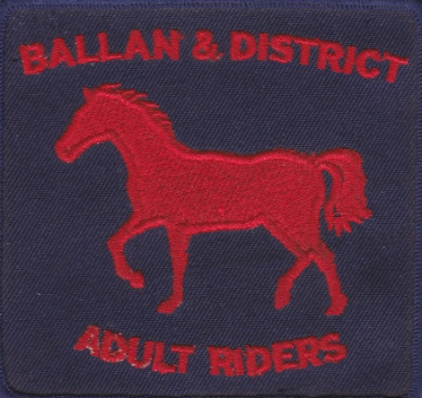
PRESIDENT – -- Lesley Sapsead 0400 014 967
TREASURER – Jane Martin 0438 347 671
SECRETARY – Naomi Benney 0417 565 060

Ballan and District Adult Riding Club
POST OFFICE BOX 108, BALLAN 3342

NEW MEMBER INFO SHEET

Grounds/Directions
Unless otherwise specified, Club rallies are held at our club grounds, Ballan Racecourse, Racecourse Road Ballan. Directions: from Crossroads trading on the Ballan-Geelong Rd take the Gordon Road (head West) for about 1km, then turn right into Racecourse Road, travel for about 1/2km, turn left into Racecourse grounds. Remember to leave the front gate closed.

Parking
There is ample parking in the area to the right of the driveway in front of day yards. Other parking is available on the left in front of day yards.

Club Rooms/Facilities
Club rooms are located at the end of the driveway, past the harness shed on the left. Toilets are located across from the club rooms in the concrete tanks. The club rooms are shared by other clubs as well; the BADARC has several boxes of equipment, including tea, coffee, sugar, mugs, along with a fridge & BBQ, which members are welcome to use.

Water
Horse water is available from several locations. There is a tap located at the west (Ballan) end of the day yards and between the fenced in arena and the day yards surrounded by red & white bollards.
Human water is available in the club rooms using the brass tap above the sink.

First Aid
The club has a human/equine first aid kit. The kit is located in the filing cabinet in the club rooms.

Horse Facilities
Day yards are available for members use. Flat and jumping lesions are usually held on the sand arena or in the fenced in arena. The X-country course is located to the West of the grounds going past the toilets, keeping the toilet on the left, follow track to gate into x-country paddock. Please keep this gate closed at all times, Note there are livestock (sheep) sharing the x-country paddock. All riders are required to wear a vest while out on the x-country course. Members are not to be out on the x-country course on their own.

Club Uniform
The club colours are Navy and Red. White may also be included in clothing or saddle cloth. The club logo is available to be embossed onto your clothing or saddle blanket at ‘Budget Embroidery’, 98 Bridge Mall, Ballarat. From time to time saddle blankets and clothing are available from the club. There is no uniform require to be worn at club rallies.

Rally Day Requests
In the weeks prior to a rally, the Rally Co-ordinator will email members re rally details. Members are required to respond to the Rally Co-ordinator by the Tuesday prior to the rally as to whether you are coming or not. The Rally Co-ordinator will then plan the rally and send out a time table for all participants. We encourage all members to attend for the entire day, participating, by watching and helping out each other as well as riding your horse, and enjoying a social lunch gathering of all members.

